AWS CODE PIPELINE
- CI/CD Workflow : Jenkins vs AWS
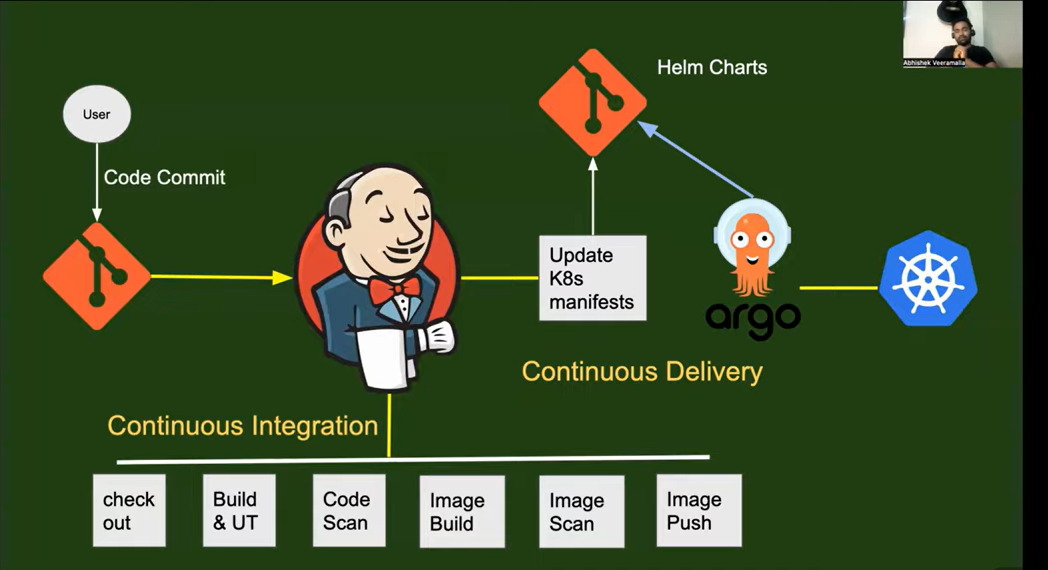

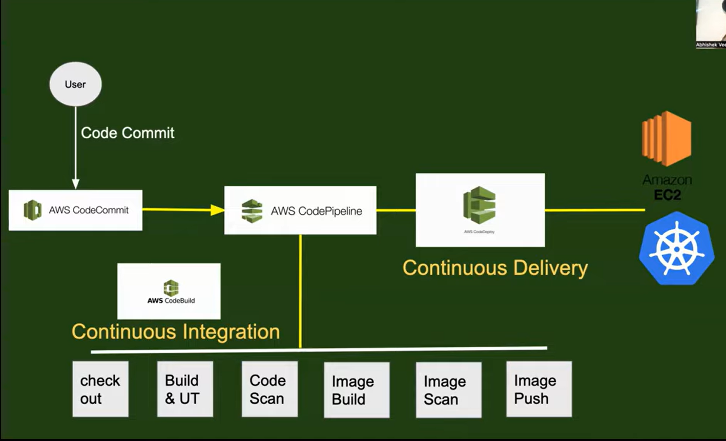

- AWS CI Pipeline:
Sample python app- aws-devops-zero-to-hero/day-14/simple-python-app at main · iam-veeramalla/aws-devops-zero-to-hero

Set Up GitHub Repository
The first step in our CI journey is to set up a GitHub repository to store our Python application's source code. If you already have a repository, feel free to skip this step. Otherwise, let's create a new repository on GitHub by following these steps:
- Go to github.com and sign in to your account.
- Click on the "+" button in the top-right corner and select "New repository."
- Give your repository a name and an optional description.
- Choose the appropriate visibility option based on your needs.
- Initialize the repository with a README file.
- Click on the "Create repository" button to create your new GitHub repository.
Great! Now that we have our repository set up, we can move on to the next step.

Configure AWS CodeBuild
In this step, we'll configure AWS CodeBuild to build our Python application based on the specifications we define. CodeBuild will take care of building and packaging our application for deployment. Follow these steps:
- In the AWS Management Console, navigate to the AWS CodeBuild service.
- Click on the "Create build project" button.
- Provide a name for your build project.
- For the source provider, choose "Github" and connect to github using oauth or github tokens.
Also provide the github repo url.
- Configure the build environment, such as the operating system, runtime, and compute resources required for your Python application.
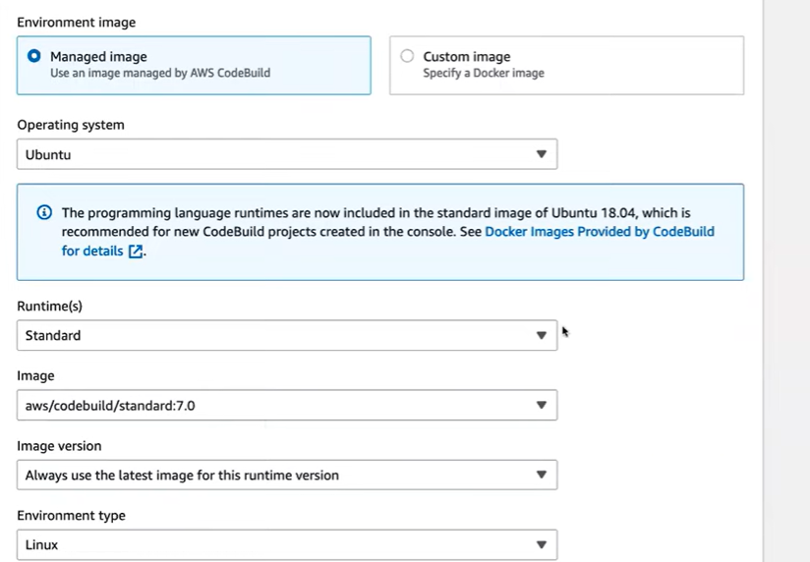

- Create a service role
- Store the docker credentials in AWS Systems Manager
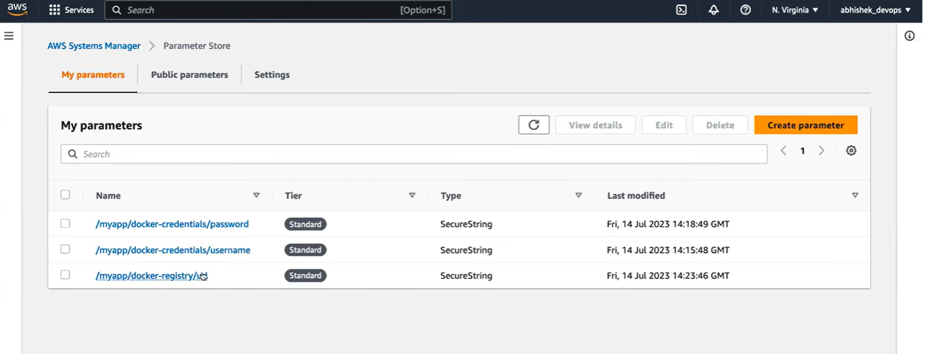
- In Build Specification,
We will use the docker credentials of AWS Systems Manager as Env Variables
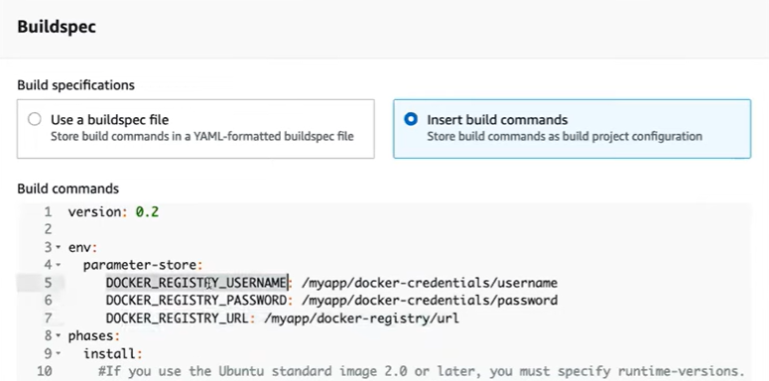
the pre-build stage will install the requirements.txt file present in our repository.
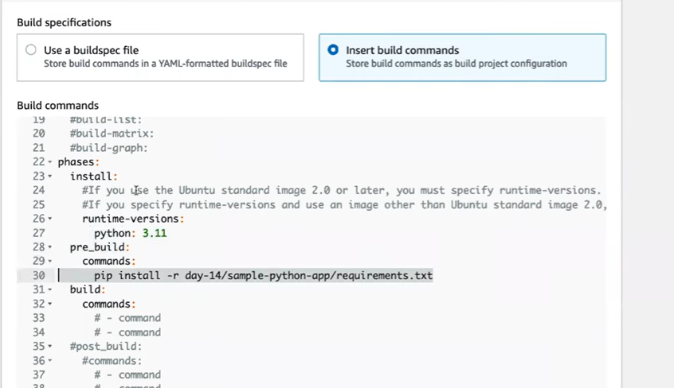

In the build stage we will do checkout, build & UT, image build and image push.
Checkout is already done in the source provider step
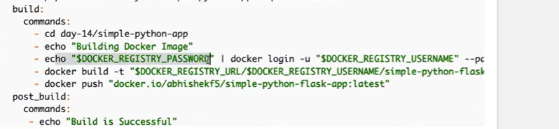
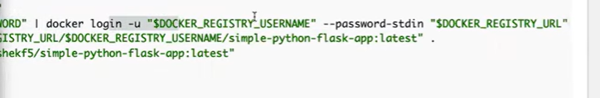
Note : put “.” at the end of docker build command
After this, create the build.
Note-1: Once we run the build, we will face error in build logs section saying the AWS Code Build should needs permission of AWS System Manager. To solve –
Go to iam role created -> add permissions-> Attach policies -> Grant SSM access.
Note-2: Another error “Cannot connect to docker daemon …”
It is because AWS CodeBuild doesn’t allow docker images to be build on the systems it provide. To solve: Go to the built project created ->edit-> environment->Click on Override Images->Enable the priviledged section

Verify: Go and Check your docker registry

Create an AWS CodePipeline

Earlier we were manually building the projects.

In this step, we'll create an AWS CodePipeline to automate the continuous integration process for our Python application. AWS CodePipeline will orchestrate the flow of changes from our GitHub repository to the deployment of our application. Let's go ahead and set it up:
- Go to the AWS Management Console and navigate to the AWS CodePipeline service.
- Click on the "Create pipeline" button.
- Provide a name for your pipeline and click on the "Next" button.
- For the source stage, select "GitHub" as the source provider.
- Connect your GitHub account to AWS CodePipeline and select your repository.
- Choose the branch you want to use for your pipeline.
- In the build stage, select "AWS CodeBuild" as the build provider.
- Select the CodeBuilt project & keep buildtype as Single build
- In the Add Deploy Stage, skip for now as it will be covered in CD stage.
- Review the pipeline configuration and click on the "Create pipeline" button to create your AWS CodePipeline.

Trigger the CI Process
In this final step, we'll trigger the CI process by making a change to our GitHub repository. Let's see how it works:
- Go to your GitHub repository and make a change to your Python application's source code. It could be a bug fix, a new feature, or any other change you want to introduce.
- Commit and push your changes to the branch configured in your AWS CodePipeline.
- Head over to the AWS CodePipeline console and navigate to your pipeline.
- You should see the pipeline automatically kick off as soon as it detects the changes in your repository.
- Sit back and relax while AWS CodePipeline takes care of the rest. It will fetch the latest code, trigger the build process with AWS CodeBuild, and deploy the application if you configured the deployment stage.

